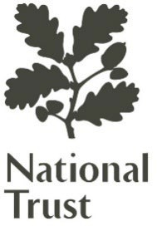

Gertrude Jekyll’s

an international beacon of gardening inspiration

Restore and Reimagine Munstead Wood for a Bold New Future

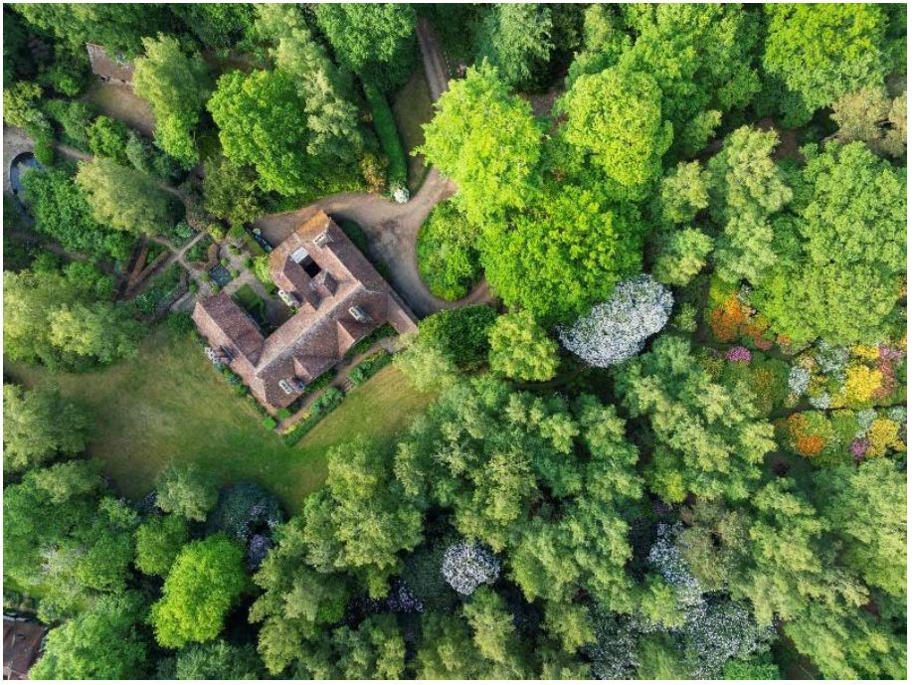
On the cusp of the twentieth century, from a small patch of Surrey, England, a remarkable woman was pioneering a new way of gardening that had a profound influence on American gardens and gardeners in her lifetime and beyond.

The National Trust, the UK's leading heritage charity, saved Gertrude Jekyll's Munstead Wood from loss. We must now raise all the funds to restore and reimagine her garden and her pioneering Arts and Crafts house, a design collaboration between Jekyll and the young Edwin Lutyens, architect of the British Embassy in Washington.

Our ambition is to restore and reimagine Munstead Wood as a vibrant space for curious minds to explore gardening, art and design, spark creativity, and grow together.

Munstead Wood will be gently adapted to create space for workshops, lectures and seminars focusing on gardening, garden design, decorative art and architectural history. There will be apprenticeships and learning opportunities for people of all ages and abilities as well as a leadership program focused on creativity and generative ideas. A dedicated studio apartment in the house will offer opportunities for students and scholars to stay in Munstead Wood and truly immerse themselves in the atmosphere. There will be a dedicated media suite for creating high quality content so people can access Munstead Wood anytime and anywhere. In the garden, there will be a small makers studio that artisans will be able to rent ensuring craft skills continue to be practiced at Munstead Wood. We will create a dedicated learning space, offering opportunities for young people to discover gardening, but also grow skills and confidence. And we will offer tours throughout the house and the garden for small groups of interested individuals, and opportunities for specialist and private events.

To initiate the delivery programs needed to restore and reimagine Munstead Wood, we first must raise the funds for the essential Munstead Wood Masterplan. Thanks to generous supporters, we have secured two thirds of the costs. We now need to raise the remaining $180,000.

'Munstead Wood's American friends so generously supported the commissioning of our Conservation Management Plan, the foundation document for any historic property and the forerunner to the Munstead Wood Masterplan. We are now entering the Design and Plan phase of the project in which National Trust and external experts will create a highly detailed masterplan. We would be honored if our American friends would consider supporting this vital next step.'
Katherine Mills, General Manager Munstead Wood

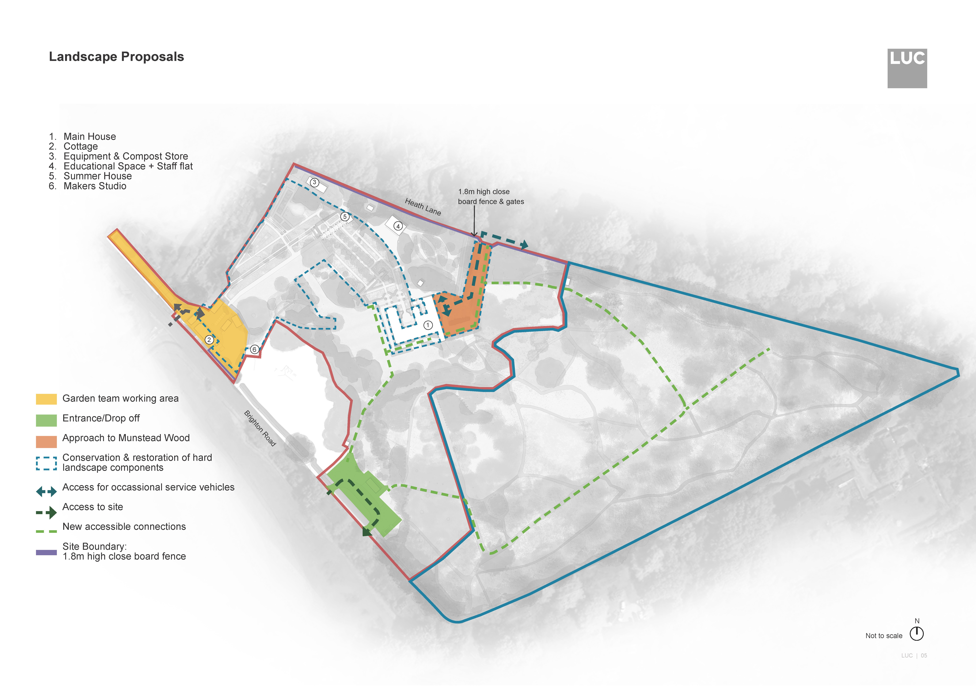

The Munstead Wood Masterplan will:
- Ensure the Jekyll/Lutyens design intent is preserved
- Commission experts to provide detailed plans
- Lead to a full planning application and consents
- Provide the foundations for program delivery
To begin the journey that will not only restore a world-significant historic site but also redefine how we engage with people through gardens and design, we need your support.

Please consider making a gift to fund the Munstead Wood Masterplan.



The National Trust is committed to fostering a strong relationship with its supporters to thank and recognize their vital contribution.
The Munstead Wood team would like to keep you updated on news, events, and how your gift has made an impact.
Please stay in touch by copying-in Munstead Wood in your communication with The Royal Oak Foundation. The email address to use is munsteadwood@nationaltrust.org.uk – thank you.




