HPS/MAG International Trip: Gardens of Northern Ireland with Optional Gardens of Dublin Extension

Wednesday, May 24 to Thursday, June 1 or Saturday, June 3, 2023
Category: Events

9-Day Northern Ireland with 2-Day Dublin Option

International Garden Trip

Wednesday, May 24 to Thursday, June 1 or Saturday, June 3

Meet at and Depart from Dublin Airport

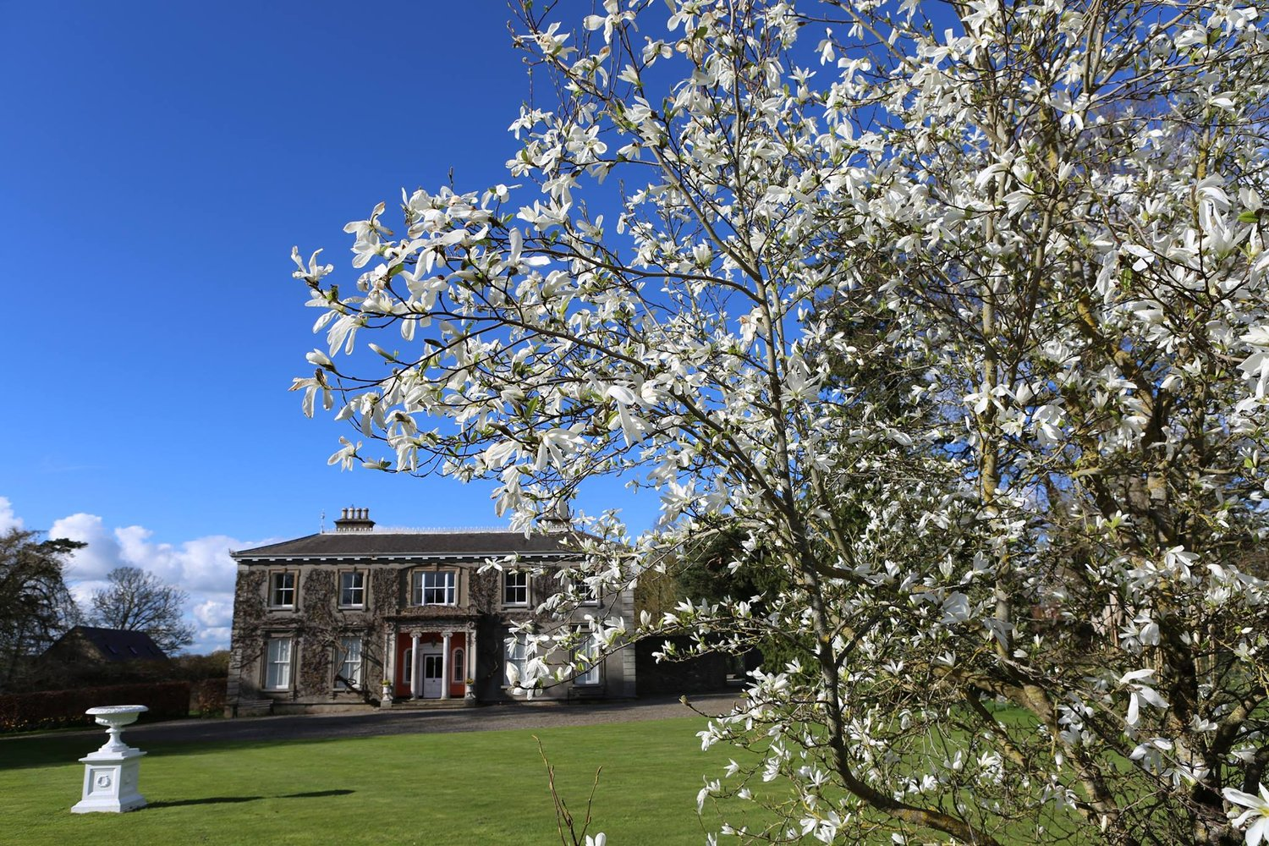

Overview
On May 24, 2023, HPS/MAG will embark on a tour of the outstanding gardens and fantastic scenery of Northern Ireland. An optional extension to tour several must-see gardens of Dublin is also being offered. After meeting at the Dublin Airport to begin our northward journey we will visit Malahide Castle, one of the oldest and most historic castles in Ireland, and the private gardens of Mark and Olive Wilkinson at Tyrrelstown House. We will settle into the 4-star Dunadry Hotel, our residence for four nights.

From our central location in Dunadry, County Antrim, we will enjoy:
- House and Gardens of Mount Stewart: These dazzling and idiosyncratic gardens bask in the micro-climate of low rainfall and humid coastal air that exists here.
- Gardens of Grey Abbey House: The Walled Garden has been restored over the years, with a vegetable garden, late summer border and shrub rose border.
- Ballywalter Par: Our visit includes a tour of the Italianate palazzo mansion guided by Lord and Lady Dunleath.
- Rowallane Garden: The liveliest gardening is to be found in the walled garden, where mixed borders are stuffed with big old shrubs and the occasional rare rhododendron animates the scene.
- Castle Ward: Apart from some traces of 18th century woodland, the garden is chiefly Victorian in character and offers memorable views over Strangford Lough.
- Ballyrobert Cottage Garden & Nursery: The garden is sub-divided into individual garden areas including the lakeside garden; the front cottage garden; the formal cottage border; the sheltered garden; and a woodland and wildlife haven.
- Glenarm Castle: This is the 400-year-old home of the Viscount and Viscountess Dunluce and their family, whose walled garden is filled with exciting flowers and specimen plants.
- A short walking tour of Belfast and a visit to the Titanic Belfast Museum, which has established itself as the city’s premier tourist attraction.

As we travel further north, we will stop at the Benvarden Walled Garden, one of the finest in Northern Ireland and visit the World Heritage site Giant’s Causeway. We will settle into the 4-star Maldron Hotel in Derry/Londonderry our residence for three nights.

From our central location in Derry/Londonderry we will enjoy:
- Glenveagh Castle Gardens: The Rhododendron Collection should be at its peak.
- Oakfield Park: Sitting in a lush landscape of parklands, lakes, mature woodlands, overlooking the distant Croaghan Mountain, the grounds include a hedge maze, sculptures, and miles of walking paths.
- Hampstead Hall: The private gardens of Liam and Nora Greene, which were landscaped starting in 1979, include an enclosed formal garden and a Japanese garden under construction.
- Brook Hall Estate & Garden: Owned and maintained by six generations of the Gilliland family since 1858, the garden and arboretum have been developed into one of the finest private collections on the island of Ireland.
- Pub lunch in Letterkenny, and a walk around the 400-year-old City Walls of Derry/Londonderry.

As we head south to Dublin we will visit Hillsborough Castle, King Charles III’s official residence in Northern Ireland. We will all stay at a comfortable hotel in Dublin and have the remainder of the day and evening free to explore Dublin.

After breakfast on June 1, 2023, at an agreed time, those not staying for the Dublin extension will transfer back to Dublin Airport for onward flights.

Cost of the Northern Ireland trip is:
£1595.00 per person based on double occupancy
£ 400.00 Single Supplement per person
$ 180.00 per person for Tour Manager and Driver gratuities and HPS donation
Included in the cost of the Northern Ireland trip:
- 8 night’s accommodation: Four nights’ dinner, bed & breakfast at the 4-star Dunadry Hotel; three nights’ dinner, bed & breakfast at the 4-star Maldron Derry Hotel; 1 night bed and breakfast in Dublin
- One lunch in Letterkenny
- Afternoon tea at Grey Abbey House
- Refreshments at Tyrrelstown House
- Entry to: Mount Stewart, Giant’s Causeway and Hillsborough Castle; the gardens of Rowallane, Castle Ward, Ballyrobert Cottage, Glenarm Castle, Benvarden, Glenveagh Castle, Oakfield Park, Hampstead Hall and Brook Hall Estate; walking tour of Derry City Walls
- Guided tours of Tyrrelstown, Grey Abbey House Gardens, Ballywalter Park and Malahide Castle
- Comfortable coaching throughout
- Services of Trevor Edwards as Tour Manager
Not included in the cost of the Northern Ireland trip:
- All lunches except lunch in Letterkenny
- Dinner in Dublin
- Gratuities for hotel and restaurant service
- Personal expenses
- Single Supplement
- Air travel
The trip is limited to 22 people and requires a minimum of 20 paying travelers.

Registration begins January 4th. We will keep a waitlist for the Northern Ireland trip once we have 22 registered travelers.

Optional 2-Day Dublin Extension

Thursday, June 1 to Saturday, June 3

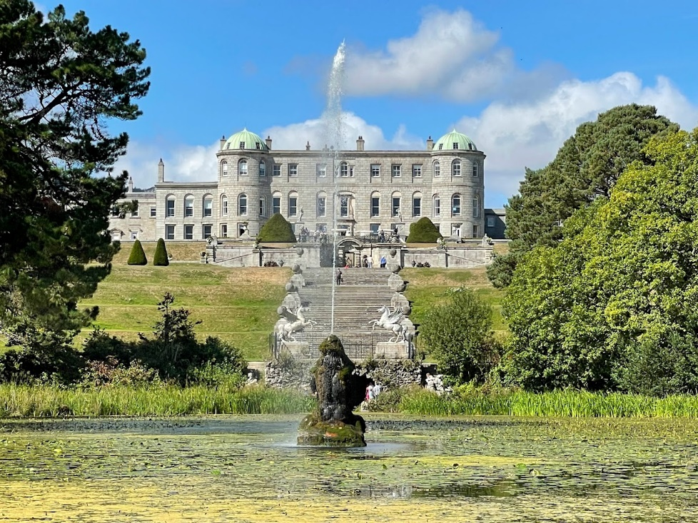
Overview
On June 1, 2023, we begin our optional Dublin extension. We will have 2 full days to see the gardens of Dublin and get to know the UNESCO City of Literature that’s twice been named Europe’s friendliest city by TripAdvisor. Dublin is a joy to explore with vibrant art, cobbled streets, hip cafés and traditional pubs.

After breakfast, we will visit Hunting Brook, home of renowned plantsman Jimi Blake and Ireland’s largest collection of ornamental grasses. We continue to Jimi’s sister’s garden at June Blake’s Garden and Nursery. June is a passionate plantswoman who grows from seeds sourced all over the world. Her garden is extensive and sits in the old cut granite farmyard of Tinode House. We will have the remainder of the day and evening free to explore Dublin.

On our second full day in Dublin, we will visit Powerscourt Gardens, Ireland’s most famous gardens, and the gardens of Killruddery, among the oldest gardens in Ireland. We will have the remainder of the day and evening free to explore Dublin.

While in Dublin, you will have the options of evening excursions to the Gaiety Theatre in Dublin to see the courtroom thriller, The Verdict, and to a performance of the Celtic Night featuring live music, traditional Irish dance and a 3-course dinner.

After breakfast on June 3, 2023, at an agreed time, will transfer back to the Dublin Airport for onward flights.

Additional Cost of the Optional Dublin Extension is:
£ 595.00 per person based on double occupancy
£ 150.00 Single Supplement per person
$ 20.00 per person for Tour Manager and Driver gratuities
Included in the cost of the Dublin Extension:
- 2 night’s accommodation bed and breakfast at Dublin hotel
- Entry to the gardens of Hunting Brook, June Blake, Killruddery and Powerscourt
- Comfortable coaching throughout
- Services of Trevor Edwards as Tour Manager
While in Dublin your evenings will be free to plan as you please. Alternatively, we will offer an optional excursion each evening:
- An optional evening excursion to the Gaiety Theatre in Dublin to see the courtroom thriller, The Verdict.
- An optional evening excursion to a Celtic Night featuring live music, traditional Irish dance and a 3-course dinner.
Not included in the cost of the Dublin Extension:
- Lunches and dinners in Dublin
- Gratuities for hotel and restaurant service
- Personal expenses
- Optional Evening Excursion to the Gaiety Theatre - price to be confirmed
- Optional Evening Excursion to the Celtic Night - price to be confirmed
- Single Supplement
- Air travel
The Dublin Extension is limited to 12 people and requires a minimum of 12 paying travelers.

Registration begins January 4th. We will keep a waitlist for the Dublin Extension once we have 12 registered travelers.

COVID-19
HPS/MAG COVID-19 PRACTICES AND POLICY FOR THIS INTERNATIONALTRIP: All HPS/MAG international trip participants will comply with all COVID-related requirements imposed by the host countries, the in-country travel company, and the COVID-related requirements, if any, of each garden host. All attendees must bring a mask in case it is required.

Additionally, to keep our members safe as we travel in close quarters for a prolonged period, we require travelers to be fully vaccinated and have the current (bivalent) booster as per current CDC recommendations. To confirm your spot on this trip, you will need to provide a copy of your current Covid Vaccination Card.

REGISTRATION

Click here to view and print the detailed itinerary _________________________________

This is a “Members Only” trip. Non-members who want to go on this trip can click here to first join HPS/MAG:https://hpsmag.memberclicks.net/index.php?option=com_mcform&view=ngforms&id=2055388#!/

Registration is by paper mail only and on a first come first serve basis. To register:

- Download and print the Registration Form
- Complete your Registration Form
- Make deposit checks payable to Hardy Plant Society/Mid-Atlantic Group
- Deposit for Northern Ireland only is $180
- Deposit for Northern Ireland and Dublin Extension is $200
- Enclose a copy of your current Covid Vaccination Card
- Mail your completed registration form, copy of your current Covid card and deposit check as per the Registration Form

Click here to view and print the Registration Form _________________________________

Hope to see you in Ireland!!

